Logical Data Extraction from an Android Device Using AFLogical OSE
EXPERIMENT NO: 07
DATE:
1. AIM
To configure an Android mobile forensics environment, establish a secure ADB bridge connection, utilize the AFLogical OSE application to perform a logical data extraction, and transfer, verify, and analyze the resulting CSV artifacts.
2. SOFTWARE / TOOLS REQUIRED
- Operating System: Windows/Linux (Kali WSL)/macOS host machine
- Forensics Tool: AFLogical OSE (Open Source Edition) APK, Android Debug Bridge (ADB) CLI utility
- Runtime Environment: Java Development Kit (JDK)
- Hardware: Target Android Mobile Device, USB Data Cable
3. DESCRIPTION
AFLogical OSE (Open Source Edition, developed by viaForensics) is an application-based tool installed via the Android Debug Bridge (ADB). It queries the device's internal databases to extract critical user artifacts—including contacts, SMS messages, MMS messages, and call logs. The extracted records are compiled and stored locally in standardized CSV (Comma-Separated Values) format, allowing investigators to easily pull, review, and document evidentiary records for investigative reporting.
Logical data extraction is a non-invasive mobile forensics technique used to gather structured data directly from an operating device's active databases and content providers without requiring root access. While physical extraction captures a bit-by-bit clone of the flash memory (enabling the recovery of deleted files), logical extraction interacts exclusively with the operating system's APIs to pull active, allocated data.

4. PROCEDURE
Step 1: Environment Setup & Device Preparation
- 1. Install Java and the Android SDK Platform-Tools (ADB) on the host workstation, adding ADB to the system PATH environment variable.
- 2. Enable Developer Options on the target Android device by navigating to Settings > About Phone and tapping Build Number seven times.
- 3. Enable USB Debugging under Settings > Developer Options.
Step 2: Connecting and Verifying the Device
- 1. Connect the Android device to the computer via a secure USB cable.
- 2. Open the Command Prompt / Terminal and verify communication using the ADB devices command:
DOS / Bash
adb devices
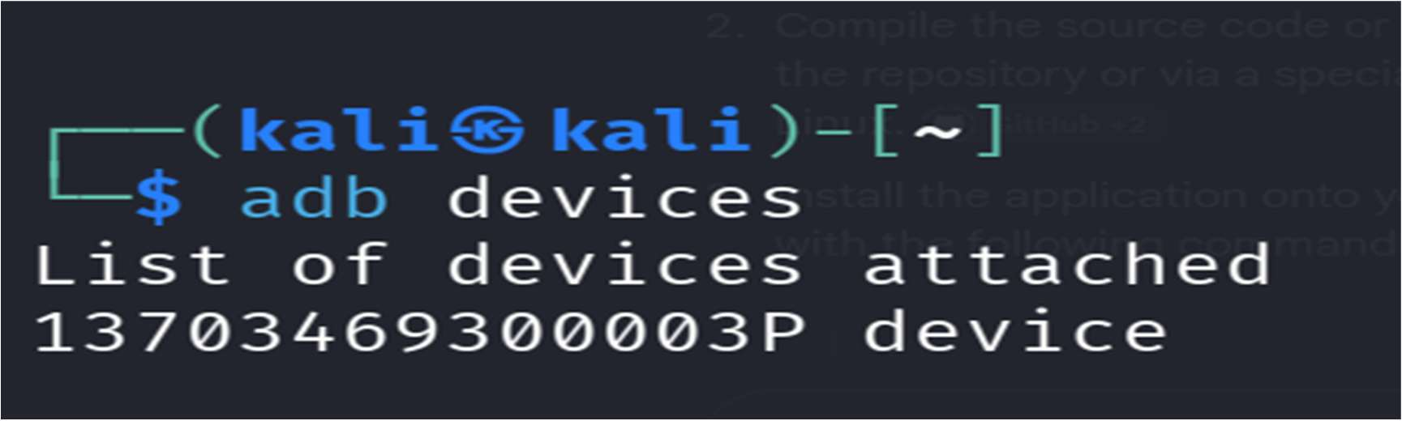
Figure 1: Terminal output displaying the successfully connected Android device via ADB
Step 3: Deploying and Executing AFLogical OSE
- 1. Navigate to the directory containing the aflogical.apk file and push/install the application onto the target device:
DOS / Bash
adb install aflogical.apk

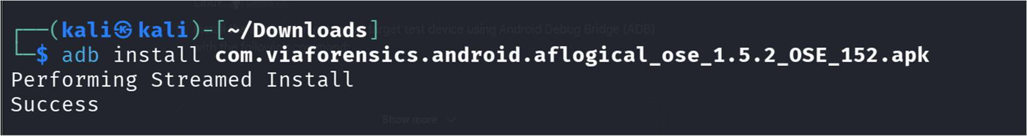
Figure 2: Successful installation of apk
- 2. Launch the AFLogical application manually on the Android device interface.
- 3. Select the desired forensic data artifacts to extract (e.g., Contacts, SMS, Call Logs) and initiate the extraction process. The utility automatically writes the compiled records into .csv files within the device's local storage directory (/sdcard/aflogical).
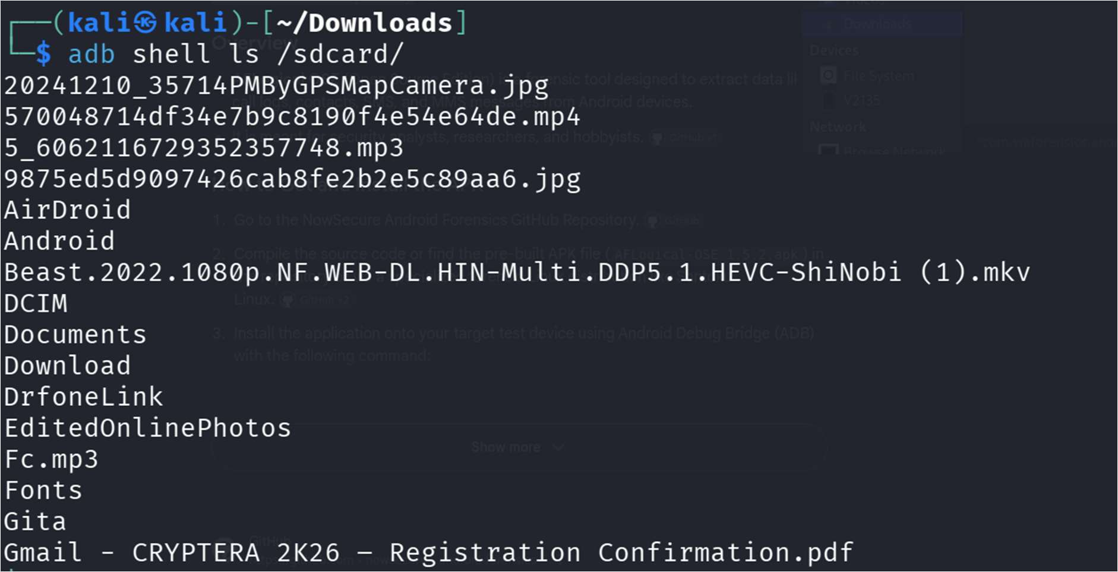
Figure 3: AFLogical OSE interface showing data category selection and extraction initiation
Step 4: Data Verification and Analysis
- 1. Navigate to the local destination directory (C:\DF\AFLogical_Evidence\ or ~/Desktop/AFLogical_Evidence) and inspect the generated CSV files using spreadsheet software or text editors to verify record integrity.

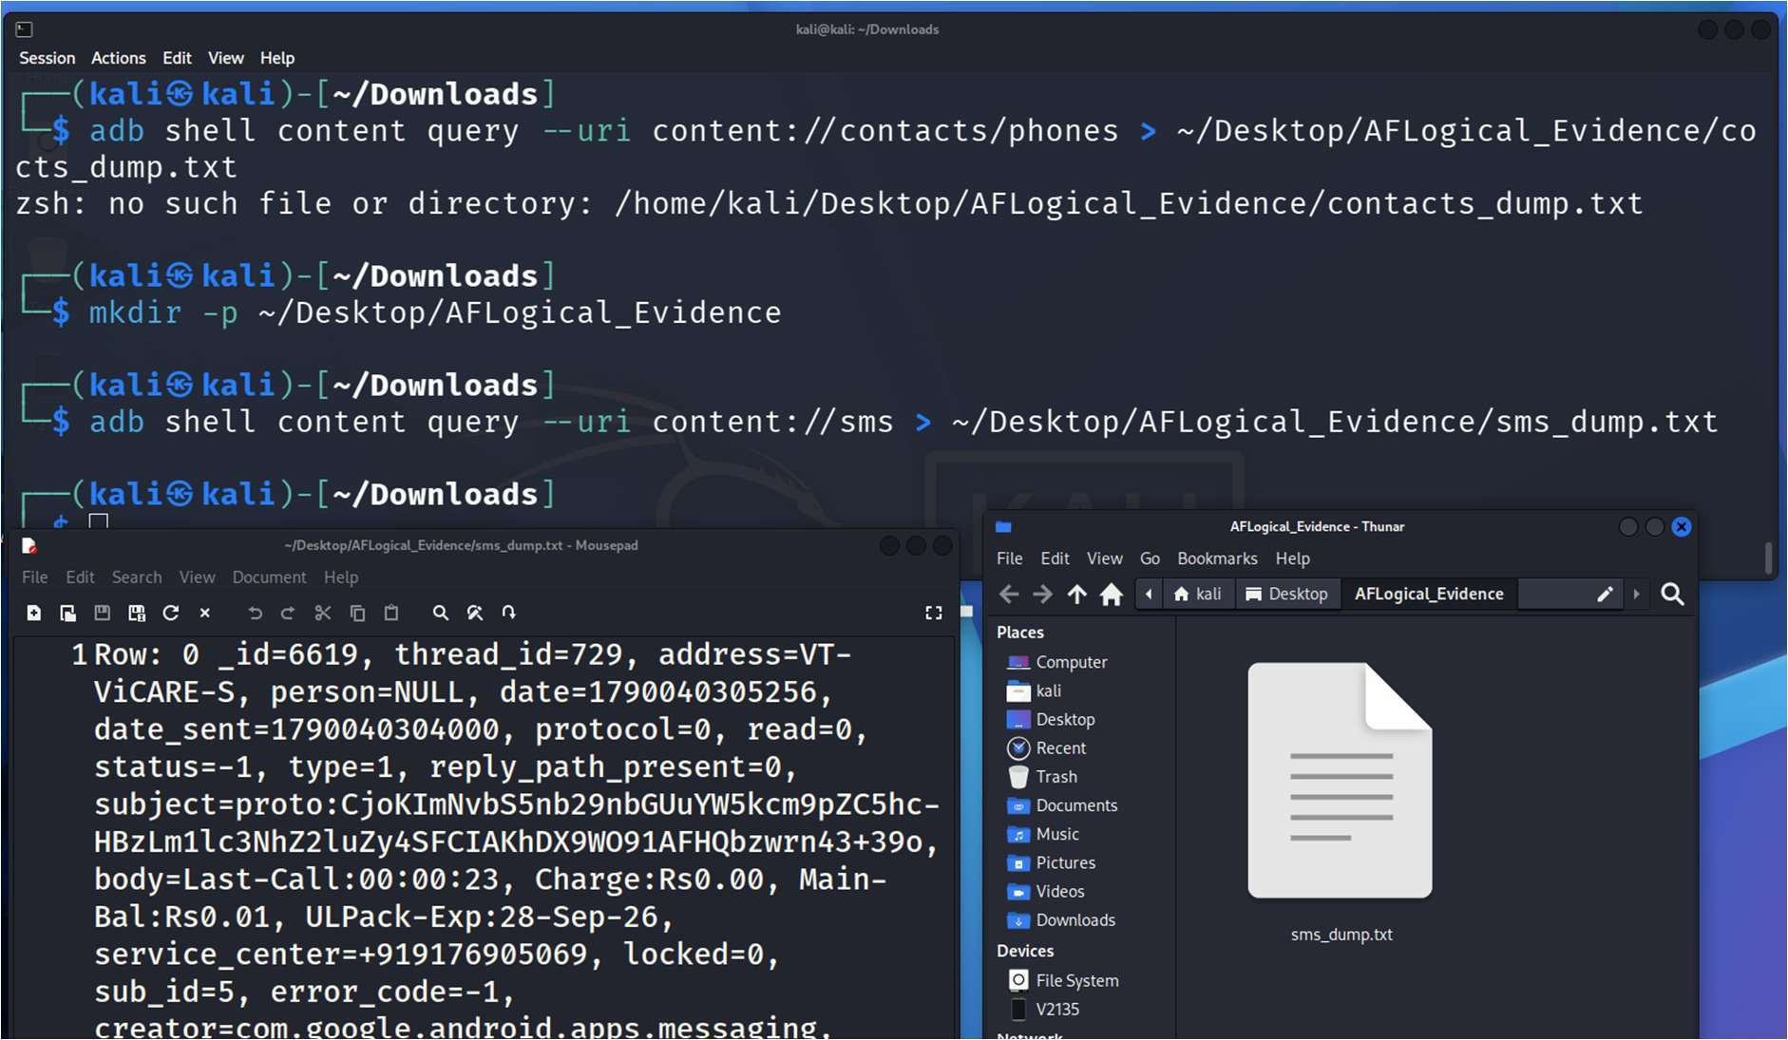
Figure 4: Examining extracted contact, SMS, and call log artifacts in spreadsheet format
Step 5: Remediation and Cleanup
- 1. Uninstall the forensic collection application from the target device to maintain forensic hygiene and restore the system state:
DOS / Bash
adb uninstall com.viaforensics.android.aflogical
- 2. Safely disconnect the device from the workstation.
5. OBSERVATIONS / FORENSIC FINDINGS
- Bridge Communication: The ADB daemon successfully initialized communication with the target device, confirming authorization and proper driver configuration.
- Application Deployment: The aflogical.apk package was successfully pushed and executed without triggering system integrity faults.
- Artifact Extraction: The logical acquisition routine successfully parsed the device's internal content providers, generating structured CSV files for communication and contact directories.

- Data Integrity: The pulled data files (contacts.csv, sms.csv, calls.csv) retained exact field parameters, timestamps, and metadata attributes necessary for evidentiary documentation.
- Timestamp Formats: Observe how the timestamps were recorded. Mobile devices often store time in Unix Epoch time (milliseconds since Jan 1, 1970) or UTC. Mentioning this shows a deep understanding of forensic data parsing.
RUBRICS
Criteria & Marks Assigned | Mark Allotted | Mark Awarded
1. GitHub Activity & Submission Regularity | 3
2. Application of Forensic Tools & Practical Execution | 3
3. Documentation & Reporting | 2
4. Engagement, Problem-Solving & Team Collaboration | 2
Total | 10
6. RESULT
Logical data extraction from the Android device was successfully executed using AFLogical OSE and ADB commands. Key user artifacts including contacts, call logs, and messaging records were extracted, securely transferred to the host workstation, and verified for forensic analysis.

